Project: Student Accommodation Payment & Management System (StayTrack)
Group: C
System Architecture
Main System Components
Component | Purpose
Flutter Mobile Application | Provides mobile functionality for the intended mobile users (students/tenants). Allows students to view their payment reference, rental information and payment history, upload proof of payment, submit maintenance requests (with an optional photo), view the status of reported maintenance requests, and view announcements.
ASP.NET Web Application | Provides web functionality for the intended web or administrative users (management and the maintenance technician). Allows management to record and verify payments, generate monthly reports on demand, manage tenant records, assign and update maintenance requests, and post announcements. Allows the technician to view assigned maintenance requests and mark jobs as complete.
Supabase Authentication | Manages authentication where required. Implements OTP-based login for all users (students, management and technicians), ensuring secure access without shared passwords.
Supabase Database | Stores information used by both applications. Hosts all persistent data including user profiles, tenant records, rooms and properties, payment records, maintenance requests and announcements. Enforces Row Level Security (RLS) for data isolation. Monthly reports are generated on demand from the payment records and are not stored.
Supabase Storage | Stores files uploaded by students: proof-of-payment documents and maintenance request photos. Proof-of-payment files are accessible only to the uploading student and management; maintenance photos are accessible alongside the maintenance request.
Users Of Each Application
User | Uses Flutter? | Uses ASP.NET? | Main Purpose
Student/Tenant | YES | NO | View personal payment reference, rental amount, rental period and payment history. Upload proof of payment. Submit maintenance requests and view the status of all reported requests. View announcements.
Accommodation Manager (Management) | NO | YES | Manage tenant records, record and verify payments (including reviewing proof of payment), generate monthly paid/unpaid reports, assign maintenance requests to a technician, update request status, and post announcements to students.
Maintenance Technician | NO | YES (restricted role) | View the maintenance requests assigned to them (including the attached photo) and mark completed jobs as complete.
Management and the Maintenance Technician use the same ASP.NET web application. Supabase Authentication returns each user's role at login, and the application shows each role only the pages and data it is permitted to use. No separate technician application is required.
Responsibility of Each Component
Component | Main Responsibilities
Flutter | Provides the mobile interface for students/tenants. Responsible for:  (1) authenticating students via OTP through Supabase Auth;  (2) displaying each student's unique payment reference, rental amount, rental period and payment history, including the status of each proof of payment;  (3) allowing students to upload proof of payment, which is stored in Supabase Storage and linked to the student's payment record with the status "pending";  (4) allowing students to submit new maintenance requests (with optional photo upload);  (5) displaying all submitted maintenance requests and their current status (pending / assigned / completed);  (6) displaying announcements posted by management; and  (7) validating user input on the device before sending data to Supabase.
ASP.NET | Provides the web-based interface for management and the maintenance technician. Responsible for:  (1) authenticating management and technician users via OTP through Supabase Auth, and showing each role only the pages it is permitted to use;  (2) recording rental payments received against specific student accounts and matching them using the student's payment reference;  (3) reviewing the proof of payment uploaded by students and marking the payment as approved or rejected;  (4) generating monthly reports on demand showing which students have paid and which have not, and allowing the report to be downloaded;  (5) managing tenant records (adding, editing and archiving tenant, room and property details);  (6) displaying a dashboard summarising outstanding payments and outstanding maintenance tasks;  (7) assigning maintenance requests to a technician and updating their status;  (8) allowing technicians to view their assigned requests and mark them as completed; and  (9) posting announcements visible to students.
Supabase Authentication | Responsible for verifying the identity of every user (students, management and technicians) before they can access any part of the system. Issues one-time passwords (OTP) for login, generates and validates JWT session tokens, and returns the user's role so that the Flutter and ASP.NET apps can direct users to the correct interface. Ensures that only authenticated users can access protected data.
Supabase Database | Responsible for persistently storing and managing all shared application data used by both the Flutter and ASP.NET apps, including: user profiles, tenant records, rooms and properties, payment references, payment records (including the link to the student's proof of payment), payment history, maintenance requests and their statuses, and announcements.  Enforces Row Level Security (RLS) policies so that students can only read their own payment and personal information, all students can view submitted maintenance requests and their status, management users can access the tenant, payment and maintenance data they are authorised to manage, and technicians can only see the requests assigned to them.  Monthly reports are generated on demand from the payment records and are not stored. The database acts as the single source of truth for both front-end applications.
Supabase Storage | Responsible for securely storing and serving files uploaded by students: proof-of-payment documents (PDFs or images) and photographs attached to maintenance requests. Files are saved to dedicated buckets.  Proof-of-payment files are kept in a private bucket and are only opened through short-lived signed URLs, so that only the student who uploaded the file and management can view them. The file path is stored in the corresponding database record (the proof URL on the payment record and the photo URL on the maintenance request) so that the applications can display the file alongside the record.
Main Data Flows
Student → Flutter → Supabase Authentication
The student enters their email and OTP through Flutter and the credentials are verified by Supabase Auth, which returns a session token and the user's role.
Student → Flutter → Supabase Storage → Supabase Database
The student uploads proof of payment through Flutter. The file is stored in Supabase Storage and a payment record linked to the file is stored in the Supabase database with the status "pending".
Student → Flutter → Supabase Database
The student submits a maintenance request through Flutter and the request is stored in the Supabase database.
Student → Flutter → Supabase Storage
The student optionally attaches a photo to a maintenance request through Flutter and the image is stored in Supabase Storage.
Supabase Database → Flutter → Student
Payment reference, rental information, payment history, maintenance requests and their statuses, and announcements are retrieved and shown to the student.
Manager → ASP.NET → Supabase Database
The manager records a payment through the web app and the payment is stored in the Supabase database.
Supabase Storage / Database → ASP.NET → Manager
The manager opens a proof of payment uploaded by a student and approves or rejects the payment; the payment status is updated in the Supabase database.
Manager → ASP.NET → Supabase Database
The manager assigns a maintenance request to a technician, updates its status, or posts an announcement through the web app.
Technician → ASP.NET → Supabase Database
The technician views the requests assigned to them (with any attached photo) and marks completed jobs as completed; the updated status is stored in the Supabase database.
Supabase Database → ASP.NET → Manager / Technician
Student records, payment records, maintenance requests and monthly report data are retrieved through the web app. The monthly report is generated on demand and downloaded by the manager.

From | To | Information Exchanged
Student | Flutter | Student enters their email and OTP to log in, and later enters payment and maintenance request details (title, description, optional photo, proof of payment).
Flutter | Supabase Authentication | Login credentials (email + OTP) are sent to Supabase Auth for verification; a JWT session token and the user's role are returned.
Flutter | Supabase Storage | The student's proof-of-payment file and any maintenance-request photo are uploaded to Supabase Storage; a file path is returned for each uploaded file.
Flutter | Supabase Database | The student's payment record (amount, payment date, month paid for, reference used, proof URL) is inserted into the payment table with status = pending. The student's maintenance request (title, description, optional photo URL, status = pending) is inserted into the maintenance_request table.
Supabase Database | Flutter | The student's own payment reference, rental amount, rental period and payment history (including the status of each proof of payment) are retrieved and displayed.
Supabase Database | Flutter | All submitted maintenance requests (from all students) and their current statuses are retrieved and displayed.
Supabase Database | Flutter | Announcements posted by management are retrieved and displayed to the student.
Manager | ASP.NET | Manager enters payment details, reviews uploaded proof of payment, assigns maintenance requests, updates maintenance statuses, posts announcements and selects the month for a report.
ASP.NET | Supabase Authentication | Login credentials (email + OTP) are sent to Supabase Auth for verification; a JWT session token and the user's role (management or technician) are returned.
ASP.NET | Supabase Database | A new payment record is inserted into the payment table and matched to a student via their payment reference. A student's pending payment is updated to approved or rejected, recording who verified it and when.
ASP.NET | Supabase Storage | Management retrieves a student's proof of payment, and management and technicians retrieve maintenance photos, through short-lived signed links.
ASP.NET | Supabase Database | Maintenance requests are assigned to a technician and their statuses are updated (pending → assigned → completed), and new announcements are inserted.
Technician | ASP.NET | Technician logs in, views the requests assigned to them and marks a completed job as completed.
Supabase Database | ASP.NET | All tenant records, payment records and maintenance requests are retrieved and displayed, including the data for the dashboard.
Supabase Database | ASP.NET | The payment records for the selected month are retrieved to show which students have paid and which have not. The report is generated on demand and returned to the manager as a downloadable file; it is not stored.
System Architecture Diagram
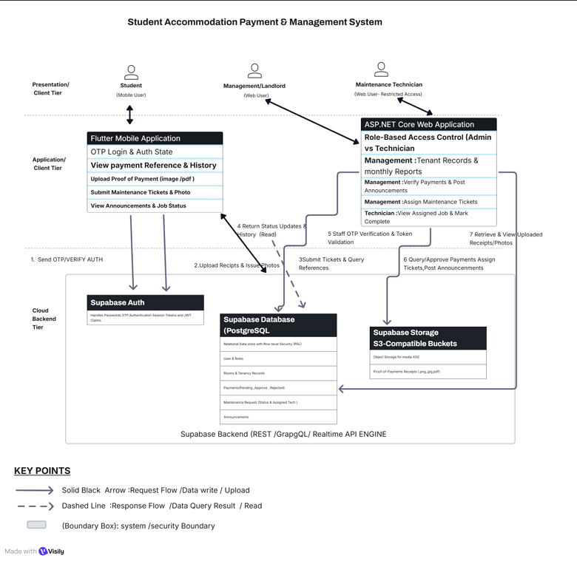
Figure 1: StayTrack system architecture
Tool used: Visily
Explanation of the Architecture
- Who uses the Flutter application. Students/tenants use the Flutter mobile application to view their payment reference, rental information and payment history, upload proof of payment, submit maintenance requests with an optional photo, view the status of reported requests, and read announcements.
- Who uses the ASP.NET application. The accommodation manager (management) and the maintenance technician use the ASP.NET web application. Management records and verifies payments, manages tenants, generates monthly reports, assigns and updates maintenance requests and posts announcements. The technician has a restricted view of the requests assigned to them and marks jobs as complete.
- What Supabase is responsible for. Supabase is the shared backend for both applications. Supabase Authentication handles OTP login and returns each user's role. Supabase Database stores all shared data and enforces Row Level Security so each user only sees what they are allowed to see. Supabase Storage holds the proof-of-payment files and maintenance photos uploaded by students.
- How Flutter communicates with Supabase. The Flutter app sends API requests over HTTPS to Supabase to log users in, upload files to Storage, and read and write records in the database. Supabase returns responses (such as session tokens, file paths and data) to the app.
- How ASP.NET communicates with Supabase. The ASP.NET app sends API requests over HTTPS to the same Supabase project to authenticate management and technician users, retrieve and update records in the database, and open uploaded files from Storage. Supabase returns the requested data to the web application.
- How the two applications form one integrated solution. Both applications connect to the same Supabase backend, so data created in one application is available in the other. For example, a student uploads proof of payment in Flutter; it is stored in Supabase; management sees it in ASP.NET and approves it; and the student then sees the approved status in Flutter. In the same way, a maintenance request submitted in Flutter appears in ASP.NET, is assigned to a technician and marked completed there, and the updated status is shown back to students in Flutter. Supabase therefore acts as the single source of truth that connects the mobile and web applications into one system.
Key Architecture Decisions
The following decisions shaped the architecture. Evidence of stakeholder confirmation is recorded where it exists.
Decision | Reason
OTP-based login instead of shared passwords or biometrics | The stakeholder did not want users sharing passwords. Biometric login is not available on every phone, so OTP was suggested and accepted as the alternative.
Payment and personal information restricted to the relevant student and management (Row Level Security) | The stakeholder stated that payment and accommodation information must not be accessible to people who are not associated with the accommodation.
Maintenance requests visible to all students | Students can see that a problem is already reported, which prevents duplicate requests, and can see whether it is still outstanding.
Students upload proof of payment, which management verifies | The stakeholder currently has to chase students for proof of payment, which can take several days.
Maintenance technician as a third user role with a restricted view | Maintenance problems are forgotten by both the stakeholder and the technician; assigning and tracking requests addresses this.
Optional photo on maintenance requests | A photo helps the technician understand the problem before attending. | [Insert evidence: confirmation from the stakeholder and date]
Monthly report generated on demand and not stored | The interview asked for an end-of-month paid/unpaid report; no archive of old reports was requested, so storing them is not needed for the prototype. | [Insert evidence: group decision, confirmed with the stakeholder on (date)]

